**MVP Project name:** Student Survival Store

**Build in:** Node JS, SQL, Pre-React, Tailwinds CSS

**Brief description:** Primary a SAAS, goods, print and product marketing platform built by students for students across all disciplines.

Filling a gap in the market for an engaging and highly discounted commerce and marketing solution for brands to market directly to students via, subscription box packages, products listed in online catalogue, direct email marketing and through social media.

Within the user dashboard the customer will be able to leave a review and rate each individual product they receive and submit a photo of themselves with the product if they wish, which will in turn for each submission after review, credit their account with SSS coins that may be collected and spent on direct purchases from the online catalogue. This will allow brands to quickly receive honest and genuine reviews of their products that they can use to improve the product or use online. The terms for photo submission of the customer with the product will be copyright of SSS at the point of submission which will open UGC marketing options for brands on a low cost, typically gifted basis.

**Ethical Goal:** Create direct access to one of the most lucrative markets for brands, especially small businesses, where there is a need for a bounce back in sales affected by Cov19.

**Site Wide Requirements:** Customer portal and dashboard, brand portal and dashboard, system portal and dash, payment processor for subscriptions and direct purchases, eCommerce catalogue, high converting landing pages, user and email marketing database, rate and review product feedback, brand digital currency, blog and articles.

**SAAS Market brief:** Currently there is no SAAS platform that exists solely targeting students or leading direct marketing campaigns in an agency style in this way. This product will create a new section within the student marketing sector and will allow brands to promote their products or service/discounts in front of an entire network of students, whether that is for pre-launch analysis/survey, user generated content, product marketing or brand awareness. Creating a complete and comprehensive suite of marketing services while delivering a high-quality product to students at a low cost.

**SWOT Analysis:**

Strengths

* Able to quickly update software and programs to improve the business operations as there is no red tape or necessary approval from higher ups as there would be in a corporate scenario
* Five star customer care as the team is small and readily available to answer any questions that may arise from customers
* Can change the marketing direction quickly if it proves undesirable as 100% is digital leading
* Minimal overheads so we can provide a great value product

Weaknesses

* Little market presence or reputation
* Small staff with specialist skill base which narrows overall team effectiveness
* Cash flow will be unreliable in the early stages of launch
* Quick expansion with lots of new hires to train and workplace mindset to instill to ensure fresh new ideas to keep up with the curve

Opportunities

* Universities want to back student led products to showcase what is possible towards the end of the course and future progression after graduation
* News highly worthy story for broadsheets with personality led drive on young enterprise
* Competitors will be slower to adopt new technologies as we adopt a social and technology first approach without need for stakeholder decision making time constraints
* New generation of customers demand the latest eco-friendly packaging and climate neutrality

Threats

* Developments in technology may slowly change in which case the product core will need to be updated to newer alternatives
* A small change in the focus of one or two competitors with already large customer bases might wipe out any market share we manage to achieve
* Price fluctuations may occur where suppliers price per product may rise and cause added base costs

**PESTLE Analysis:**

|  |  |  |  |
| --- | --- | --- | --- |
|  | External factors to consider | Factors affected within my industry | Importance to organisation |
| POLITICAL | Government policy  Political stability Tax  Industry regulations | Consumer protection rights.  Government imposed lockdowns restricting in-person shopping | High  Low |
| ECONOMIC | Exchange rates  Globalization  Economic growth/ decline Inflation  Interest rates Cost of living  Labour costs  Consumer spending habits | Uncertainty prevails in the UK business markets and investors due to the UK leaving the EU.  COVID-19 pandemic has added to poor market performance and greater dependence of online shopping.  Consumer spending habit changes put pressure on certain goods whilst others are in decline | Low  High  High |
| SOCIAL | Consumer trends/ tastes, Fashions  Consumer buying habits Lifestyle factors  Career attitudes  Work-life balance  Population demographics | Our subscription boxes and online store does cater to all within our chosen audience.  The demographic with the most disposable income sits within the London area. | High  Medium |
| TECHNOLOGY | Automation  Innovation  Disruptive technologies  Social networking  Upgrades Robotics  Artificial Intelligence  Security | E-commerce side of the business is underdeveloped and overshadowed by subscription buying.  Is our technology fit for purpose now and for the future?  How appealing is our online presence? Website ease of use for customers.  Smartphone apps for ordering goods.  Data storage confidentiality and consumer rights.  Need to improve technology for analytics and buying intelligence.  Rise in cybercrime risk to data protection and operational stability. | Low  High  High  Low  Medium  Medium  High |
| LEGAL | Employment law  Common law  Local labour law  Health and safety regulations | Wage rates and National Minimum  Wage increases yearly.  Concerns over family-friendly implications as most of these were brought in by the EU.  Peak trading periods require contractual flexibility.  Gig economy and Taylor review – implications of employment status. Compliance with the Modern Slavery Act particularly important for retail.  Introduction of workplace pensions | Low  Low  Low  Low  Medium  Low |
| ENVIRONMENTAL | Renewable materials  Sustainable resources CSR (Corporate social responsibility)  Ethical sourcing  Transportation  Procurement  Supply chain management  Future pandemics | The rise in ethically and environmentally conscious shoppers.  Ethical sourcing will push up the price up of our goods  Supply-chain disruptions as PPE garments are the main focus. | High  Medium  Low |

There are 5,385 students enrolled at Falmouth University. If 10% of the students on campus subscribed to a SSS monthly box, at £15 per box (539 x £15 = £8085) this could be expanded to all 164 universities in the UK. There are currently 2.38 million students studying at higher level in the UK, taking a conservative 0.1 percent total of all students in the UK signing up (23800 x £15 = 357000) in revenue each month.

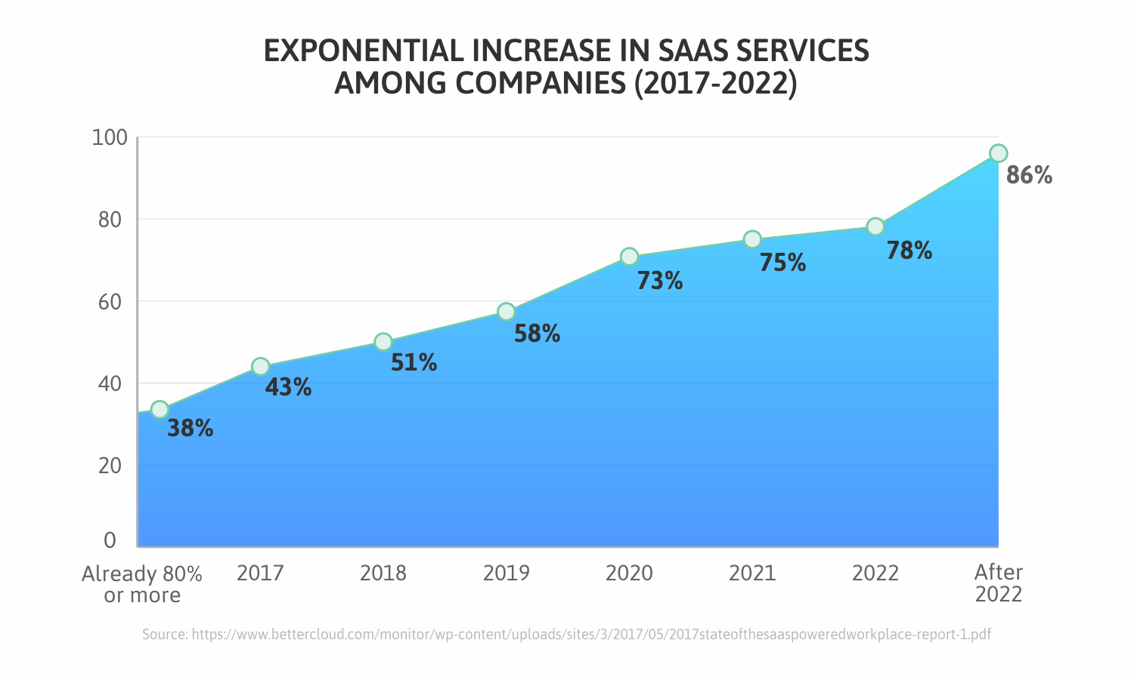

*Pricing comparison chart cost for brand advertisement/marketing

**Target Demographic:** Accessible for any students in education at a higher level only across the UK.

**Future Growth and Expansion:** There are a huge number of possibilities of growth for this business model. From removing UK student restrictions which would open the business to brands worldwide and a much larger customer base. Other channels of revenue include SSS merchandise and SSS own brand products able to be added to the online catalogue creating a low-cost high revenue stream further growing the SSS brand and awareness, opening possible links for direct sales at university stores further embedding the business within the student marketing sector.

**Proposed Branding:**

Student Survival Store, portrayed as a fun, cheap and cheerful subscription service and store. Engaging design and UX for students of several different disciplines and interests. The site will be presented clean and minimalist with accents of gaming and student paraphernalia.

**Font:** Lightbox 21 Bold

**Logotype:**



**Color Scheme:**

#A9FF22 Green

#000000 Black

#ffffff White

**Subscription Boxes:**

Single standalone checkout/sign-up page with multiple dropdown or selector options to customize subscription details;

* Interval (the frequency of when a delivery is send, 1,2,3 months)
* Size (number of items inside the box)
* Male/Female/Unisex (this needs to be an option selected during initial account creation)
* Accept free gifts added to box (this will be one off special bonus gifts added along with paper/print marketing materials paid for by brands)

**Requirements Expanded:**

Customer portal and dashboard

* To manage subscription and frequency: 1, 2 or 3 months
* Leave reviews and submit UGC photos for SSS credit
* Check SSS credit and spend in online catalogue

Brand portal and dashboard

* To manage product stock at SSS
* See reviews and download UGC photos

System portal and dashboard

* Manage customer subscriptions, payments, catalogue orders and approving reviews

Payment processor for subscriptions and direct purchases

* Major debit cards, credit cards, apple & google pay (Stripe)
* Re-occurring purchases and individual non-subscription purchases

eCommerce catalogue

* Direct purchasing of partner brand products for sale online found inside subscription boxes

High converting landing pages

* Per brand & campaign social ads to maximize conversion rate on subscriptions

User and email marketing database

* Database in?
* In built email newsletter program?

Rate and review product feedback system

* Within the customer dashboard and linked to credit system and system dash so each review and piece of UGC can be vetted and approved before showing in brand dashboard

SSS digital currency

* Worth proportional to £GDP?

Blog and articles

* For targeted SEO, paid brand articles and new releases to subscription boxes